|  |  |  |  |  |  |  |  |  |
| --- | --- | --- | --- | --- | --- | --- | --- | --- |
|  |  | **P3090712.JPG** |  |  | **_MG_4611.JPG** |  | **_MG_4632.JPG** |  |
| **_MG_4653.JPG** |  |  |  |  |  |  |  |  |
|  |  |  |  |  |  |  |  |  |
|  |  |  |  |  |  |  |  |  |
| **_MG_4565.JPG** |  |  |  |  |  |  |  |  |
|  |  |  |  | **_MG_4692.JPG** |  |  |  | **_MG_4592.JPG** |
| **_MG_4538.JPG** |  |  |  |  |  |  |  |  |
|  |  |  |  |  |  |  |  |  |
|  | **_MG_4695.JPG** |  |  |  |  |  |  |  |

|  |  |  |
| --- | --- | --- |
| NSW Department of Education & Training |  | 2557 |
|  | | |
| 2010 Annual School Report | | |
| Herons Creek Public School | | |
| NSW Public Schools – Leading the way | | |



Our school at a glance

Students

In 2010, Herons Creek Public School had an enrolment of 22 students from Kindergarten to Year Six drawn from families living in the Herons Creek and Camden Haven Community of Schools area.

Staff

At Herons Creek Public School this year there has been a relieving Principal for terms 1-2. A permanent Principal was appointed term 3. A temporary teacher was employed five days a week while all other positions remained the same with a School Administration Manager and a General Assistant.

All teaching staff meet the professional requirements for teaching in NSW public schools.

Significant programs and initiatives

*Reading for Life*

The Reading for Life Program initiated in 2008 continued this year. It involved our students and some of the residents from a retirement home in Laurieton. The students read books aloud to the residents who visited. The texts were then discussed and great talking and listening interaction took place. The students also visited the Nursing Home throughout the year . In term one during Seniors Week we held a technology day, where the students tutored the residents in computer, interactive whiteboard and digital camera technology . The students also presented a creative and performing arts concert at Laurieton Hall for all local senior citizens.

*Camden Haven Community of Schools*

Camden Haven Community of Schools is a learning community established to enhance the educational opportunities of all students attending Camden Haven High School and its feeder schools. In 2010 our students showcased their talents at the Camden Haven Arts Festival for Schools.

*Active After- School Communities*

The Active After- school Communities program is a national program that provides Australian primary school aged children with access to free, structured physical activity programs in the after-school timeslot. Herons Creek Public School participates in this program three afternoons a week. The children were able to participate in sports such as learn to surf, circus skills, tennis, yoga, martial arts, gymnastics and hockey.

[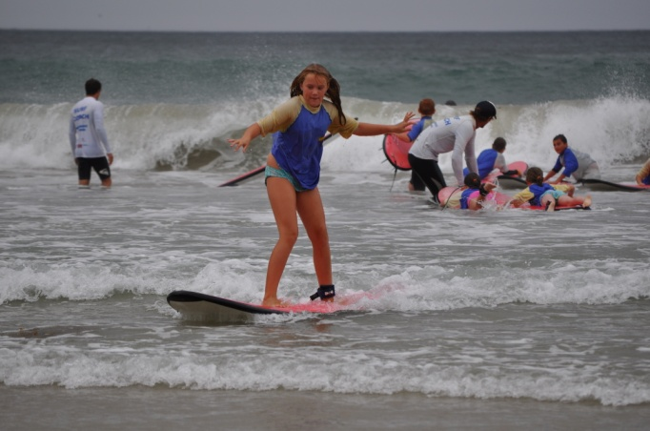](javascript:void(0))

*Dance Group*

Herons Creek Public School students performed for the CHAFFS concert and were then invited to perform at the District Dance festival concert in Kempsey. They entered the Port Macquarie Dance Eisteddfod and achieved a Highly Commended.

*Speech and Drama Eisteddfod*

All of our students entered the Port Macquarie Speech and Drama Eisteddfod in the group choral poetry section where they won first place.

*Environmental Education*

Environmental Education is a focus at Herons Creek Public School. We have an established vegetable patch. This year we completed the construction of our recycled bottle green house, built composting bays and a chicken coup. All students are encouraged to compost all food scraps. We also established our environmental outdoor classroom.

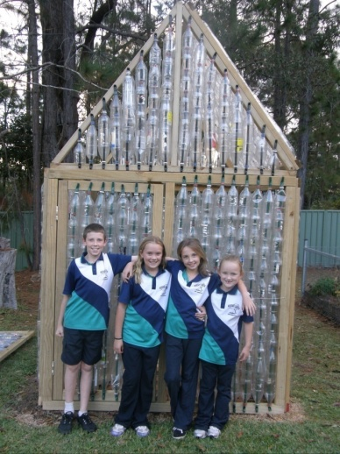

Student achievement in 2010

Literacy – NAPLAN Year 3

One student sat the NAPLAN test this year. Owing to the small number of students detailed results cannot be reported due to privacy reasons.

Numeracy – NAPLAN Year 3

One student sat the NAPLAN test this year. Owing to the small number of students detailed results cannot be reported due to privacy reasons.

Literacy – NAPLAN Year 5

Five students sat the NAPLAN test this year. Owing to the small number of students detailed results cannot be reported due to privacy reasons.

Numeracy – NAPLAN Year 5

Five students sat the NAPLAN test this year. Owing to the small number of students detailed results cannot be reported due to privacy reasons

Messages

Principal’s message

Herons Creek Public School takes pride in its welcoming environment and supportive teaching and learning programs which value every student and build on their strengths.

It has been my privilege to work as relieving principal for term one and two and continue in my role as principal permanently.

It has been a successful and positive year for Herons Creek Public School.

The students, staff, parents and school community have worked hard as an enthusiastic team to promote the school and its welcoming, positive environment.

Our school has upheld our school motto

**‘Excellence with Enjoyment’**.

I certify that the information in this report is the result of a rigorous school self-evaluation process and is a balanced and genuine account of the school's achievements and areas for development.

Nikki Ward



P & C and/or School Council message

Our school enjoys strong support from its parents and the local community. An enthusiastic core group of parents have been active in promoting the school and supporting its activities.

We have held a number of fund raising activities this year including two BBQ’s at Bunnings Warehouse.

P&C funds have been used to supplement excursion costs and mathletics for the students

A very successful working bee was held and was attended by staff and parents. We painted inside the toilet block, the weather shed, outside of the classroom and beautified the gardens.

Joanne Diamond

Student representative’s message

We have greatly enjoyed our time at Herons Creek Public School. As school leaders we have always tried to assist the younger students and be inspiring role models.

We have really enjoyed being involved in all of the extra activities this year such as learn to surf, get hooked fishing program, tennis, yoga and hosting the “School’s Out” program on the local FM radio station.

We sincerely thank our wonderful teachers and support staff. We will really miss everyone next year.

Molly McLaren, Kate Rackley, Hayley Coenraad, Jack Diamond and Chelsee Kubiak

School context

|  |  |  |  |  |  |
| --- | --- | --- | --- | --- | --- |
|  | **Year** | **2007** | **2008** | **2009** | **2010** |
| **School** | **K** |  |  | 93.7 | 92.7 |
|  | **1** |  |  | 97.9 | 91.0 |
|  | **2** |  |  | 93.3 | 95.5 |
|  | **3** |  |  | 89.5 | 94.7 |
|  | **4** |  |  | na | 93.8 |
|  | **5** |  |  | 93.9 | 98.9 |
|  | **6** |  |  | 95.8 | 89.4 |
|  | **Total** | 96.5 | 93.8 | 93.4 | 93.0 |
| **Region** | **K** |  |  | 92.5 | 93.4 |
|  | **1** |  |  | 92.3 | 93.2 |
|  | **2** |  |  | 92.4 | 93.3 |
|  | **3** |  |  | 92.6 | 93.2 |
|  | **4** |  |  | 92.6 | 93.3 |
|  | **5** |  |  | 92.4 | 93.2 |
|  | **6** |  |  | 92.2 | 92.9 |
|  | **Total** | 93.3 | 92.8 | 90.1 | 93.2 |
| **State DET** | **K** |  |  | 94.3 | 94.7 |
|  | **1** |  |  | 93.7 | 94.2 |
|  | **2** |  |  | 94.0 | 94.4 |
|  | **3** |  |  | 94.1 | 94.5 |
|  | **4** |  |  | 94.0 | 94.5 |
|  | **5** |  |  | 94.0 | 94.4 |
|  | **6** |  |  | 93.6 | 94.0 |
|  | **Total** | 94.0 | 94.1 | 92.1 | 94.4 |

Student information

It is a requirement that the reporting of information for all students must be consistent with privacy and personal information policies.

Student enrolment profile

|  |  |  |  |  |  |
| --- | --- | --- | --- | --- | --- |
|  | **2006** | **2007** | **2008** | **2009** | **2010** |
| **Male** | 4 | 5 | 6 | 5 | 7 |
| **Female** | 6 | 6 | 7 | 7 | 12 |
|  |  |  |  |  |  |

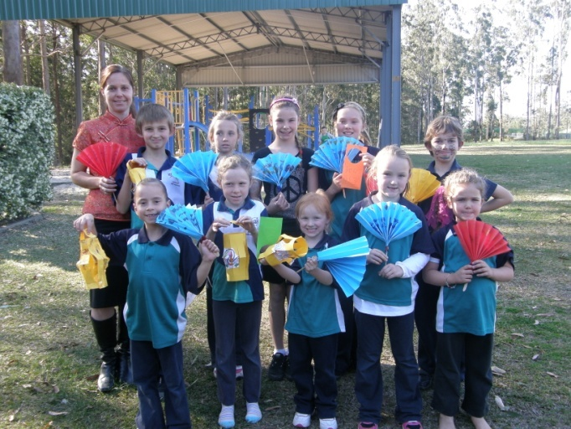

China Day

Attendance profile for 2010

Management of non-attendance

Student non-attendance is managed by the Principal who liaises closely with the local home school liaison officer.

Class sizes

In March 2003 the Government announced its commitment to publish primary class sizes in annual school reports in order to provide parents with as much local information as possible.

The following table shows our class sizes as reported at the 2010 class size audit conducted on Wednesday 17 March 2010.

|  |  |  |  |
| --- | --- | --- | --- |
| **Roll Class** | **Year** | **Total per Year** | **Total in Class** |
|
| K-6 | K | 3 | 21 |
|  | 1 | 2 | 21 |
|  | 2 | 4 | 21 |
|  | 3 | 2 | 21 |
|  | 4 | 4 | 21 |
|  | 5 | 1 | 21 |
|  | 6 | 5 | 21 |
|  |  |  |  |

Staff information

It is a requirement that the reporting of information for all staff must be consistent with privacy and personal information policies.

In 2010 Herons Creek School staff comprised of

1 Primary Principal 6

1 (5 days) Release from face to face/supplementary/ Principals relief teacher

0.4 (2 days) School Administration Manager

0.2 (1 day) General Assistant

Staff establishment

|  |  |
| --- | --- |
| Position | Number |
| **Principal** | 1 |
| **Deputy Principal(s)** | 0 |
| **Assistant Principal(s)** | 0 |
| **Head Teachers** | 0 |
| **Classroom Teachers** | 1 |
| **Teacher of Emotional Disabilities** | 0 |
| **Teacher of Mild Intellectual Disabilities** | 0 |
| **Teacher of Reading Recovery** | 0 |
| **Support Teacher Learning Assistance** |  |
| **Teacher Librarian** | 0 |
| **Teacher of ESL** | 0 |
| **Counsellor** |  |
| **School Administrative & Support Staff** |  |
| **Total** |  |

The National Education Agreement requires schools to report on Indigenous composition of their workforce.

We have no Indigenous employees.



Cross Country Age Champions for Small Schools Carnival

Staff retention

In term 2 2010, Miss Nikki Ward was appointed permanent principal of Herons Creek Public School. Miss Natalie Browne was employed five days a week in a temporary teaching position. All other staff remained unchanged.

Teacher qualifications

All teaching staff meet the professional requirements for teaching in NSW public schools.

|  |  |
| --- | --- |
| **Qualifications** | **% of staff** |
| **Degree or Diploma** | 100 |
| **Postgraduate** |  |

Financial summary

This summary covers funds for operating costs and does not involve expenditure areas such as permanent salaries, building and major maintenance.



A full copy of the school’s 2010 financial statement is tabled at the annual general meetings of the School Council and/or the parent body. Further details concerning the statement can be obtained by contacting the school.

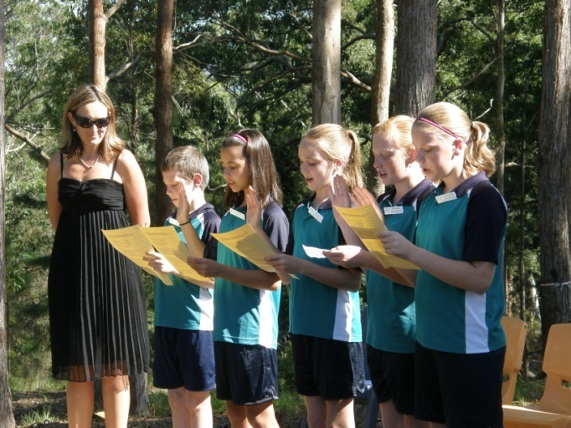

2010 School Leaders

School performance 2010

Achievements

Arts

***Dance Group***

Herons Creek Public School students performed wonderfully at the Camden Haven Arts Festival for Schools (CHAFFS) and the District Dance festival concerts this year.

They also performed at the Port Macquarie Dance Eisteddfod achieving a highly commended.

The students performed as part of the mass choir on the CHAFFS concert night.

***Speech and Drama Eisteddfod***

All students participated in the Port Macquarie Speech and Drama Eisteddfod in the small schools choral poetry section. The students did a commendable job and achieved first place.

Sport

The students at Herons Creek Public School are always encouraged to participate in the activities at school for sport and physical education.

The students had a very successful year in sport, with many individuals and teams achieving highly.

All the students participated in cricket, soccer, AFL and rugby league clinics that visited the school this year.

Our swimming program has continued this year with sport in term four. The intensive swimming scheme was held in December for two weeks for all students.

Herons Creek won the small schools handicap points score at the small schools swimming carnival in Wauchope.

Three of our students were awarded small schools age swimming champions- Kate Rackley, Molly McLaren and Jacob Asquith.

Hugh Rackley also achieved exceptional results in the pool. He was awarded the silver medal at the State Swimming Championship for 50m freestyle.

The Small Schools’ Athletics Carnival was held at Wauchope in term 3 where all our students performed very well in all of the events.

Herons Creek won the small schools handicap points score.

Jack Diamond, Molly McLaren, Mia Bales and Sara Asquith were awarded small schools age champions.



Hugh Rackley was extremely successful in shot put and discus becoming a NSW State Finalist in the AWD category for shot put and winning a gold medal for discus at the State Athletics Carnival. He was also selected to represent New South Wales at the National Titles.

All students competed at the small schools cross country carnival in term two. Three of our students achieved first place. Jack Diamond- 13 years, Piper Ward-8/9 years and Mia Bales- 5/6years.

Herons Creek Public School participated in the small schools soccer gala day with our Stage 3 team winning the competition undefeated. Our Stage 2 and Stage 1 teams also achieved wonderful results.

We also participated in the inaugural small schools tennis completion.

Other

*Premiers Spelling Bee Competition*

Molly McLaren and Maddison Ward represented our school at the Premiers Spelling Bee competition. Both students performed exceptionally well with Molly making it to the semi-finals.

*Tournament of the Minds*

Our school entered a team in Tournament of the Minds. The team were commended for their outstanding performance.

*Eagles Lodge Friendship Competition*

Herons Creek Public School won a weekend stay for all students and teachers at Eagles Lodge, a local bed and breakfast. The students scrapbooked what friendship means to them.

***Laurieton Showtime Parade***

Herons Creek Public School for the first time entered a float in the Laurieton Show time parade. We were extremely successful being awarded two first places- Most Humorous Float and Best Overall Float.

***TimberTown Scarecrow Competition***

Herons Creek entered the inaugural TimberTown Scarecrow Competition and won first place.

Students were also involved in a number of curriculum based activities and excursions such as

* Gymnastics Day
* Master Chef
* Duncan Ball visiting author
* Jump Rope for Heart
* Kendall Festival- our dance group were invited to perform.
* Major excursion to Sydney
* Anzac Day march
* Osmosis movie making
* Astronomy sleep over at school
* Mexican Christmas sleepover at school
* Wombat Stew performance
* Easter Hat Parade

Academic

In the National Assessment Program, the results across the Years 3, 5, 7 and 9 literacy and numeracy assessments are reported on a scale from Band 1 to Band 10.

The achievement scale represents increasing levels of skills and understandings demonstrated in these assessments.

Yr 3: from Band 1 (lowest) to Band 6 (highest for Year 3)

Yr 5: from Band 3 (lowest) to Band 8 (highest for Year 5)

Literacy – NAPLAN Year 3

One student in Year 3 completed the NAPLAN literacy test for 2010. Owing to the small number of students detailed results cannot be reported due to privacy reasons.

Numeracy – NAPLAN Year 3

One student in Year 3 completed the NAPLAN literacy test for 2010. Owing to the small number of students detailed results cannot be reported due to privacy reasons.

Literacy – NAPLAN Year 5

One student in Year 5 completed the NAPLAN literacy test for 2010. Owing to the small number of students detailed results cannot be reported due to privacy reasons.

Numeracy – NAPLAN Year 5

One student in Year 5 completed the NAPLAN literacy test for 2010. Owing to the small number of students detailed results cannot be reported due to privacy reasons.

Minimum standards

The Commonwealth Government sets minimum standards for reading, writing, grammar and punctuation, spelling and numeracy for years 3, 5, 7 and 9.

The performance of the students in our school in the National Assessment Program – Literacy and Numeracy is compared to these minimum standards. The percentages of our students achieving at or above these standards are reported below.

Percentage of Year 3 students in our school achieving at or above the minimum standard in 2010

|  |  |  |  |  |  |  |  |  |  |  |  |  |  |  |  |  |  |  |  |  |  |  |  |  |  |  |  |  |  |  |  |  |  |  |  |  |  |  |  |  |
| --- | --- | --- | --- | --- | --- | --- | --- | --- | --- | --- | --- | --- | --- | --- | --- | --- | --- | --- | --- | --- | --- | --- | --- | --- | --- | --- | --- | --- | --- | --- | --- | --- | --- | --- | --- | --- | --- | --- | --- | --- |
| |  |  |  |  |  | | --- | --- | --- | --- | --- | | **Percentage of Year 3 students achieving at or above minimum standard** | | | | | | | **Reading** |  |  |  | 50 | | **Writing** |  |  |  | 50 | | **Spelling** |  |  |  | 50 | | **Punctuation and grammar** | | |  | 50 | | **Numeracy** | |  |  | 50 | |  | |  | |  | |  | |  | |
|  |  | | | | | | | | | |
|  |
|  |  | |  | |  | |  | |  | |
|  |  | |  | |  | |  | |  | |
|  |  | |  | |  | |  | |  | |
|  |  | | | | | |  | |  | |
|  |  | | | |  | |  | |  | |
| Percentage of Year 5 students in our school achieving at or above the minimum standard in 2010   |  |  |  |  |  | | --- | --- | --- | --- | --- | | **Percentage of Year 5 students achieving at or above minimum standard** | | | | | | | **Reading** |  |  |  | 100 | | **Writing** |  |  |  | 100 | | **Spelling** |  |  |  | 100 | | **Punctuation and grammar** | | |  | 100 | | **Numeracy** | |  |  | 100 |   D:\DCIM\100OLYMP\PA191188.JPG |  | |  | |  | |  | |  | |
| Y:\_MG_4612.JPG |  |  | |  | |  | |  | |  |
| |  | | --- | |  | |  |  | |  | |  | |  | |  |
| Significant programs and initiatives  Aboriginal education  Aboriginal perspectives were included in all units to foster empathy and understanding of issues. The Aboriginal Liaison Officer visits were always very welcomed. The students completed Aboriginal art designs from traditional stories and made boomerangs during NAIDOC week celebrations. Staff completed the Cultural Awareness training. A grant was also attained to establish a bush tucker garden.  Multicultural education  Multicultural Education is addressed across the curriculum and includes all students at Herons Creek Public School. As the school population is all of Anglo-European background, school planning ensures that the students experience other cultures.  Chinese language and culture lessons were introduced to all students, kindergarten to year six during 2010, led by a volunteer member of the community.  A staff member was trained as an anti-racism contact officer within the school environment. It is their role to ensure that instances of racism are dealt with effectively, to ensure a continuing harmonious school environment.  Respect and responsibility  Students have been guided to show respect for themselves, others and the environment through explicit teaching and a range of classroom initiatives including social skills program facilitated by the support teacher behaviour based on the Aussie Five Fair Rules program.  A culture of caring for all school members is strongly encouraged and is modeled by all staff members. This culture is also strongly supported by the school community. |  |  | |  | |  | |  | |  |
| **Music**  A talented student from Camden Haven High School provides the students of Herons Creek Public School the opportunity to learn the keyboard and guitar. Our students have found this a rewarding experience. |  |  | |  | |  | |  | |  |
|  |  |  | |  | |  | |  | |  |
|  |  |  | |  | |  | |  | |  |
| Y:\_MG_4548.JPG |  |  | |  | |  | |  | |  |
|  |  |  | |  | |  | |  | |  |

**Connected Learning**

The school continued to enhance our technology programs available at the school with the installation of our connected classroom, the purchase of an interactive whiteboard for our Stage One classroom and ongoing teacher training and support.

Progress on 2010 targets

Target 1

**Students will be reading at or above their chronological age in terms of comprehension.**

Our achievements include:

* Purchasing of extensive resources to enhance student’s learning.
* Students were bench marked twice a term to track progress.

* Employment of an extra teacher to support the classroom teacher in literacy groups.

**Target 2**

**Enhanced quality teaching practices to improve levels of achievement for students in line with school targets in numeracy.**

Our achievements include:

* Newman’s Analysis explicitly taught to students from Kindergarten to Year Six.
* New staff trained in Newman’s Analysis.
* Purchasing a mathletics subscription for every child.
* Employment of an extra teacher to support classroom teacher in numeracy groups.

**Target 3**

**Student outcomes reflect a significant increase in the provision of strategies to support gifted and talented students.**

Our achievements include:

* Students completed digital movie making workshops culminating in student’s work being presented at the Osmosis Opening Ceremony in Port Macquarie.
* Entering a team in the Tournament of the Minds Competition.
* Two students participated in the Premier’s Spelling Bee competition.
* Our gifted and talented students participated in Newton’s Maths Challenge, Australian Maths competition and Newcastle Permanent Maths competition.

**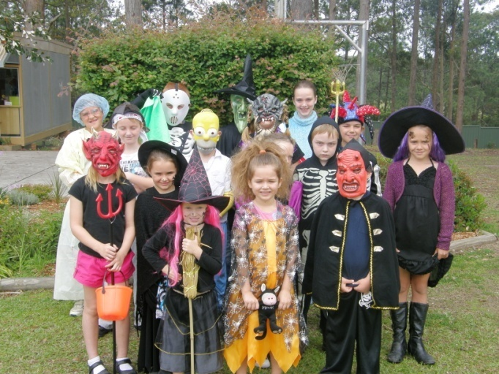**

Key evaluations

It is a requirement for all NSW public schools to conduct at least two annual evaluations – one related to educational and management practice and the other related to curriculum. In 2010 our school carried out evaluations of Enter text here

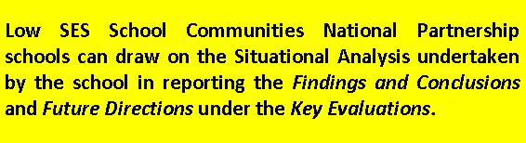

Educational and management practice

Teaching

Background

Parents, staff and pupils were asked to give their opinions on a range of issues related to teaching practices in the school.

Findings and conclusions

* Parents agreed that the way teachers managed the class helped their child learn for example the economic classroom.
* Parents supported the way the principal worked and liaised with parents to effectively make educational improvements for example the funding of a second teacher so students can be split K-2 and 3-6 for literacy and numeracy.
* Student and teacher responses indicated that the teaching structures in place maximised student learning time and assisted all students to learn at their own pace.
* Findings have indicated that the school has been successful in providing good teaching practices for all students.

Future directions

With the increasing student numbers we will closely monitor that the high standard of teaching practices continues.

Curriculum

PDHPE

Background

PDHPE has been a focus this year with much school improvement in the variety of activities this year.

Findings and conclusions

Conversations were had with staff, parents and students to measure and evaluate the effectiveness of the PDHPE program this year. This evaluation concluded that

* Parents, staff and students all see Active After Schools Community Program as a rewarding program. This program has given the students the opportunity to participate in many sports they have never tried before.
* Teachers were trained and supported in Drug Education, a parent information session was held.
* Parents, teachers and students all agree that a time allocated fruit break is important to encourage good nutrition.
* The students loved participating in the fruit and vegetable month competition.

Future directions

* Continue to apply for Active After School funding for as long as it is available.
* Continue to have a fruit break.

Parent, student, and teacher satisfaction

In 2010 the school sought the opinions of parents, students and teachers about the school.

Their responses are presented below.

The opinions of staff were sought through a number of ways through staff surveys, teacher assessment and review meetings and discussions at staff meetings. All staff indicated that they were highly satisfied with the school operation and achievements in 2010.

The evaluation meeting, informal discussion, P&C meetings were all sources for parent opinions about the school. They were all extremely satisfied with the operation and achievements for 2010.

Professional learning

Throughout the 2010 school year, staff were able to take part in professional development which included;

* Child Protection
* Emergency Care
* Persuasive Text
* Active After Schools
* Merit Selection
* Jolly Phonics
* Anti-racism contact officer training
* Connected Classroom
* Golf
* Auswim
* Cultural Awareness
* Sue Larkey- Autism
* Best Start
* Aboriginal Education
* Keep them Safe- Child Protection



School development 2009 – 2011

Targets for 2011

Literacy

Numeracy

Target 1

**Enhanced quality teaching practices to improve levels of achievement for students in line with school targets in numeracy.**

Strategies to achieve this target include:

* Teachers to train in TOWN (Taking off with Numeracy)
* Teachers to train in TEN (Targeted Early Numeracy)
* Continue to use Newman’s Analysis to improve student outcomes for problem solving.

Our success will be measured by:

* Tracking every student using the TOWN and TEN assessment strategies.
* Improvement evident as measured by school based assessment and NAPLAN results in identified strand.

**Target 2**

**Enhanced quality teaching practices to improve levels of achievement for students in line with school targets in literacy.**

Strategies to achieve this target include:

* Teachers to train in accelerated literacy and implement strategies in class programs.
* Teachers to train in small school reading recovery program and utilise in class programs.

Our success will be measured by:

* Improvement evident as measured by school based assessment and NAPLAN results in identified strand.

About this report

In preparing this report, the self-evaluation committee has gathered information from evaluations conducted during the year and analysed other information about the school's practices and student learning outcomes. The self-evaluation committee and school planning committee have determined targets for the school's future development.

**Nikki Ward**  Principal

**Natalie Browne** Classroom Teacher

**Kerrie McKiernan** School Administration Manager

**Joanne Diamond** P&C President

**John E Williams** School Education Director

School contact information

Herons Creek Public School

5499 Pacific Highway, Herons Creek NSW 2443

Ph: 02 65857125

Fax: 02 65857004

Email: heronscrk-p.school@det.nsw.edu.au

Web: www.heronscrk-p.schools.nsw.edu.au

School Code: 2157

Parents can find out more information about Annual School Reports, how to interpret information in the reports and have the opportunity to provide feedback about these reports at:

<http://www.schools.nsw.edu.au/asr>



Twice a term all the students of Herons Creek presented the Schools Out program for the local FM station



Our Year Six students

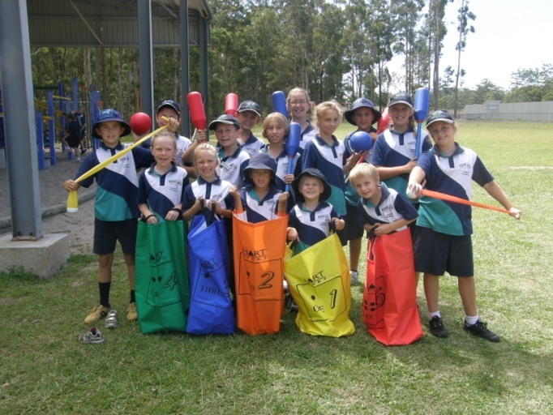

Our school collected lots of Coles Sports vouchers



Space Day